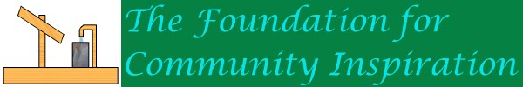

About Us and Budukwaa Community Centre

The Foundation for Community Inspiration is looking to raise money in aid of its objective which is to reduce poverty, provide for people in need, and in doing do improve the quality of peoples lives.
The Foundation for Community Inspiration is a small family charity based in Stoneygate, Leicester. It was set up by Dr Julia Piper in 2007. The Foundation was set up when Dr Piper and her son (David) decided to visit a friend in Ghana who had successfully set up a fruit processing factory (Blue Skies) in highly challenging conditions near Ghanain capital Accra. The friend, (Anthony Pile) had successfully helped create over 1000 local jobs by setting up a plant where electricity is rare, there are no sewer systems, a poor road network, exchange rate issues, and a very demanding schedule which requires daily exports of fruit to be consistently exported by air freight to well known brands like Sainsburies in Europe.
During the initial visit to Ghana, we saw how Blue Skies struggled with daily problems like unrealistic employee demands, potential loss of the use of air freight because of air pollution regulation, and we saw the challenges of driving cargo via lorries through a road network where congestion was intense because navigating enormous potholes in dusty roads meant vehicles had to drive on the opposite side of the road to the extent that there really were no sides to the road, just a mass of vehicles driving in all directions, and getting stuck in traffic jams. Accidents and deaths because of these problems were high, and it meant that it was very difficult for Blue Skies to get deliveries of fruit to the airport in time, and losing a shipment could mean losing a major contract with a major brand.
Despite all of this Blue Skies managed to stay afloat and profit. More importantly though, it won the Queens award for sustainability with its medical practice, (reopened and enhanced by our Foundation), one of the few medical practices in the country, its access via satellite to internet facilities for the employees, library, recycling, healthy employee meals and the jobs it gave the community, all rare feats in the country. In addition the factory supported the local communities, partly through our foundation, by proving materials for local schools via partnership with Sheffield based Yewlands schools, by providing electricity, water facilities and other amenities.
During our stay the Foundation provided medical assistance such as helping employees with back pains, assessed the medical centre for what new equipment it needed which we later donated, toured the factory (details of which we cannot pass on), met with key staff who were very helpful, and friendly, as were the general Ghanain community in looking after us and being our hosts. In addition to tasting the fruit at source in the factory such as mango and pineapple and also at the plantations, and viewing the factory facilities the Foundation assisted further by providing acupuncture to a disabled nurse, who has now recovered from a stroke, once a much admired member of the Blue Skies medical facility, and viewing local areas, such as plantations, schools, schools for the blind and disabled, and local villages. We also visited Cape Coast Castle, where the British once shipped slaves from Ghana to Americas. At the time of our visit if was the 50th anniversary of Ghanas independence.
After our first visit the Foundation officially opened, and looked to assist in the poor Central Region areas of Ghana that we had visited. These villages lacked clean water, schooling, sanitation, electricity, medical facilities, people lived in mud based houses which suffered from heavy erosion in the rains. There were four villages we eventually looked at, including Budukwaa who we eventually supported in building a Community Centre which doubled up as a school for children. The villages wanted, apart from the facilities mentioned schools, and community centres. Our initial meetings were with the chiefs of the communities, who later made requests for facilities including some of those mentioned above and the community centre. The eventual construction of the centre was managed by Blue Skies, the local village partook in the construction and was eventually completed.

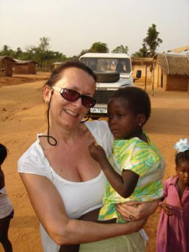
Dr Julia Piper in a village in Ghana, with a friend!

Ghana Central Region – Budukwaa Program
The aim with the Budukwaa program was to help our partners in Africa Blue Skies help the local communities by providing them with what they needed. After visiting Ghana and assessing the requests from the communities, we decided to build a community centre in the poor rural central regions of the country where Blue Skies sourced some of its fruit, where there were a lack of some of the basic amenities required for a better life.
During our first visit to the Blue Skies freshly-cut-fruit processing factory near Nsawam, Ghana, Dr Julia Piper and David Piper, visited several rural villages in the Central Region. These villages were typical of the more impoverished communities in the south of the country and lived in mud huts, some with no clean water, no sanitation, erosion problems, no health facilities, lack of cooking facilities, high under 5 death rates, malaria, not so much AIDS/HIV in these areas, lack of healthy meals, long distances to walk to school, low gender inequality and so on.
The villages though were helped by having a few jobs at the local plantations which were used by Blue Skies to source the fruit for cutting. Typical foods they ate included starch based meals such as Fufu. After visiting the sites, and talking to the chiefs, and after returning to the UK, the foundation send a formal request to Blue Skies to go to the villages to assess what they wanted. In the response the villages submitted requests for water holes, septic pit latrines, facilities to prevent erosion of the lands, teachers quarters, which were used to attract teachers which would then enable children to be taught at schools and community centres.
The foundation visited Ghana again in 2009 in order to decide what to build and eventually built a Community Centre/Kindergarten which was used in the Budukwaa village and allowed children to go to school. The school was partly funded by the Yewlands Group of schools, based in Sheffield who came with us on the trip and also by Private General Practice Services. The total cost for the centre was around £10k.

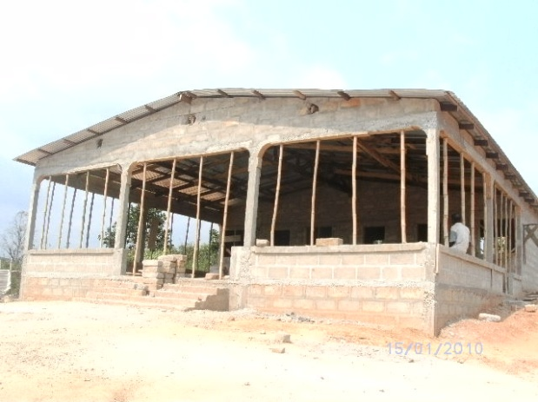
The Community Centre under construction
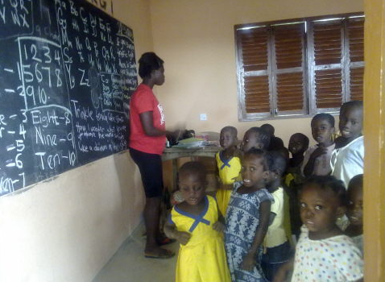
Some children using the classroom facilities in the community centre
The facility in February 2010 had a student population of 25. The Yewlands schools brought items including a football, books, crayons, posters and pencils in a subsequent visit. The centre also had a water collection system with a polytank for the children, a see saw, a slide, and merry go round. There is a concrete curb and gutter around the building to prevent erosion which tends to occur around local buildings.
You can read more about the program, by visiting www.f4ci.co.uk, clicking on ‘programs’, and clicking on the ‘Ghana Program’.

